PROJECT REPORT

**TOPIC: Identification of Lymphocyte WBC in blood**

BY: RAJAS V PRASAD

Student Of

Medical Electronics

Engineering

M S Ramaiah Institute

Of Technology

Bangalore 560054

**TABLE OF CONTENTS:**

**- Objective**

**- Introduction**

**- Methodology**

**- Code explanation**

**- Results**

**-Conclusion**

**Objective:**

From blood smear microscopic image , Identify the WBC cells and in that mark the Lymphocytes (which are closer to circular in shape).

**Introduction:**

Blood contains Red blood cells (RBC) and White blood cells (WBC). WBC are more darker and bigger in size. There are five types of WBC : Neutrophils, Monocytes, Eosinophils, Lymphocytes, Basophils. Here the Lymphocytes are darker and circular in shape compared to other types.

**Methodology:**

**STEP1: Understanding the input image**

Input for this program are peripheral blood smear images which are read by the program with the function call as “**imread()”.**

The chosen image is read by this call.

Then we give **“size()”** to let our program know that we need to consider the size of the input image.

The output is shown as;

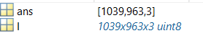

Finally we title this image to be read as **“original image”**

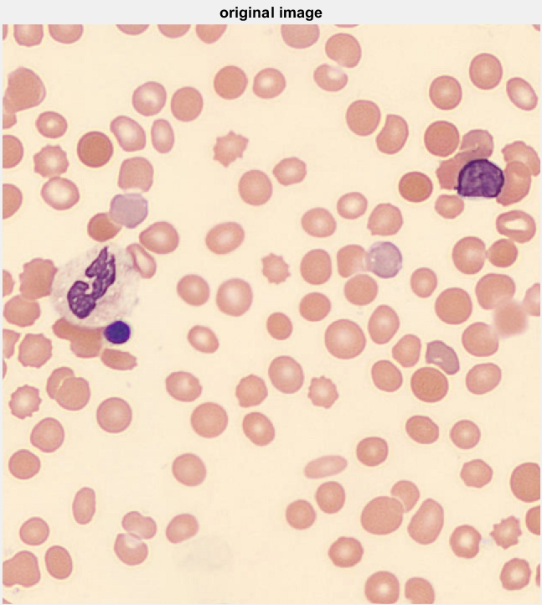

**STEP2: Strel() functionality**

Here we reconstruct the input image morphologically (erosion & dilation) by using ‘disk’ shaped structuring element with the radius of ‘n’ unit (we have considered n=1 to capture all the cells in the image).

The ‘**Strel’** first argument signifies the shape of structural element to be identified. The syntax is given as : **strel(“Shape”, “Size”)** along with the size defined in second argument.

eg:

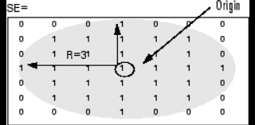 (this fig has Radius=3unit)

Here the requirement is to choose **“disk”** shaped objects inside the image. To do the morphological operation, it creates binary matrix by choosing the dark components of the original image and labelling it as 1 and rest with 0 values

**STEP3: ‘imopen()’ (morphological opening of image by**

**performing erosion and then dilation)**

With this binary matrix, conduct erosion process:

Construct structuring element of disk with radius 1 and mark the centre element as “local origin” (1). Taking this local origin (1) we match the binary matrix by each pixel with its matching adjacency value and mark them as “1” otherwise with “0”.

Take this erosion binary matrix and conduct dilation process:

Consider the same structuring element pattern and perform dilation process by matching it with the eroded image. Fill the binary matrix accordingly ,call this as dilated binary matrix.

Consider the dilated binary matrix values and apply this on the original image. This is called as the morphological Reconstructed image.

We perform the **“imopen()”** call on **rgb** components that represent the Red, Green, Blue pixel value components for the image being considered.

--------------------------------------------------------------------------------------------------------------------------------------

**STEP4: Conversion to binary image**

**red=rgb(:,:,1)**represents the position of red component inside the pixel and red is standard as the **1st component**.

**green=rgb(:,:,2)**represents the position of green component inside the pixel and green is standard as the **2nd component**.

**blue=rgb(:,:,3)**represents the position of blue component inside the pixel and blue is standard as the **3rd component**.

These mark the position of RGB components inside the pixel.

Construct a binary image and categorise the darker shades in the picture by matching the decimal code value as pixel values or grey level intensity values. For **red component** we set the **threshold limit** between **25-199** and **green** b/w **0-130** and **blue** b/w **120-225** for each pixel, by marking them with value “1” rest are “0”. Also label “1” as “Holes”

Using **imfill()** function, construct greyscale image by filling those pixel with white color which are categorise as “Holes”. Rest of the pixels the ‘non holes’, filled with Black color. (The below image is an example of how hole filling happened to a threshold binary image).

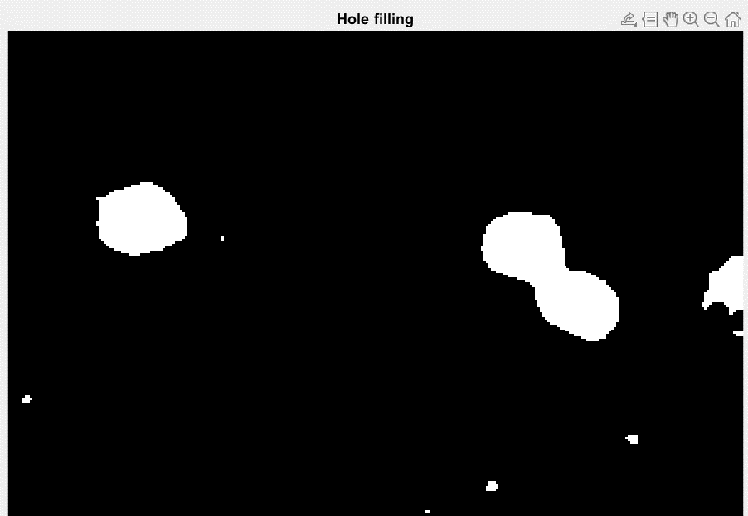

--------------------------------------------------------------------------------------------------------------------------

**STEP5: Morphological operation on binary image**

(After the Red, Green and Blue pixel value components are provided with threshold values of grey level intensity, we now perform the morphological operation)

1. **Bwmorph(erode)** – This function clears the noise in the segmented image by erosion method so that the boundary pixels are distinct foreground compared to background.

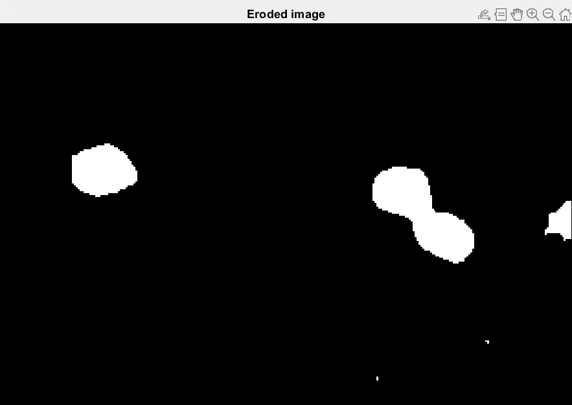

(Erosion of the previous example binary image)

1. **Bwmorph(dilate) -** This functionmakes the segmented boundary more smoother by dilation process. The smoothing intensity is **1.2**.

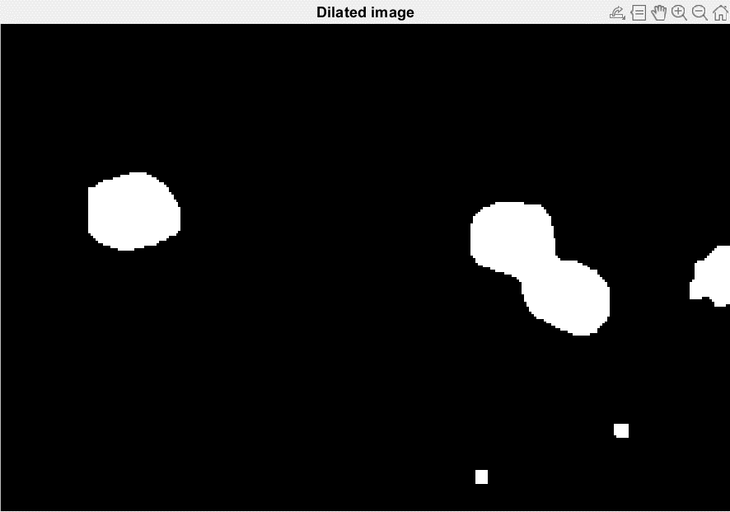

1. **imfill(holes) -** After the dilation and erosion where we get a sharp and smooth segmented objects fill those with holes to make it more brighter.

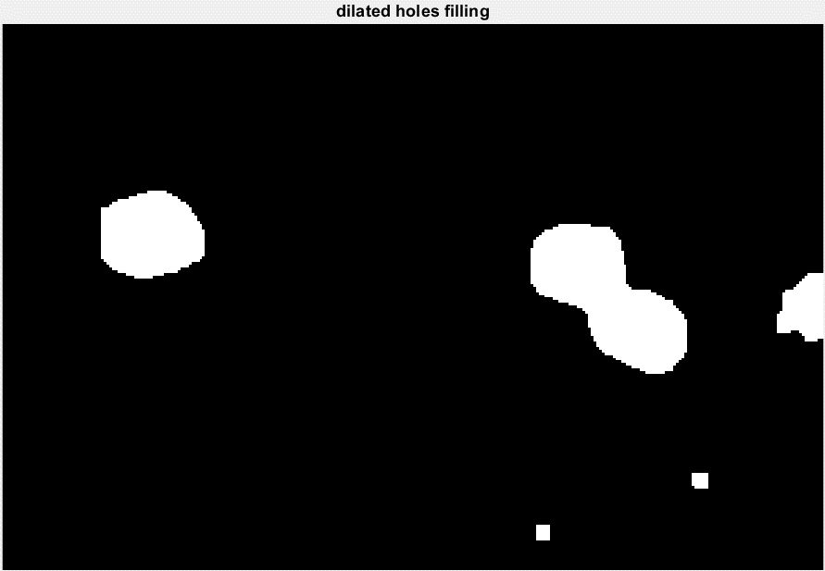

1. **Bwareaopen(filename,300)** - This is to take out foreground objects which are **300** or less pixels in size, to remove all the small objects.

**STEP 6: To find the number of cells in given image**

By using **imfindcircles()** our objective now becomes to find total number of cells.

We do this by cicular hough transform (**A basic feature extraction technique used in digital image processing for detecting circles in imperfect images**).

From the reconstructed image we select the circles that range between **2-80** radius values which have an ‘**ObjectPolarity’** i.e. set to ‘**bright**’ and having a **‘Sensitivity**’ factor of **0.764**.

(**Here Object Polarity means finding the circles objects which are brighter than the background and Sensitivity factor will adjust the amount of bright circular objects that are to be found**)

Next we label the new image which has found the appropriate circular objects as ‘**Circled objects’.**

Now we calculate the number of cells using the ‘**length()**’ function. Along with this we attach ‘**viscircles()**’ function that marks the found circles with a red boundary that are identified by the call ‘**imfindcircles()**’.

Finally we get the output as;

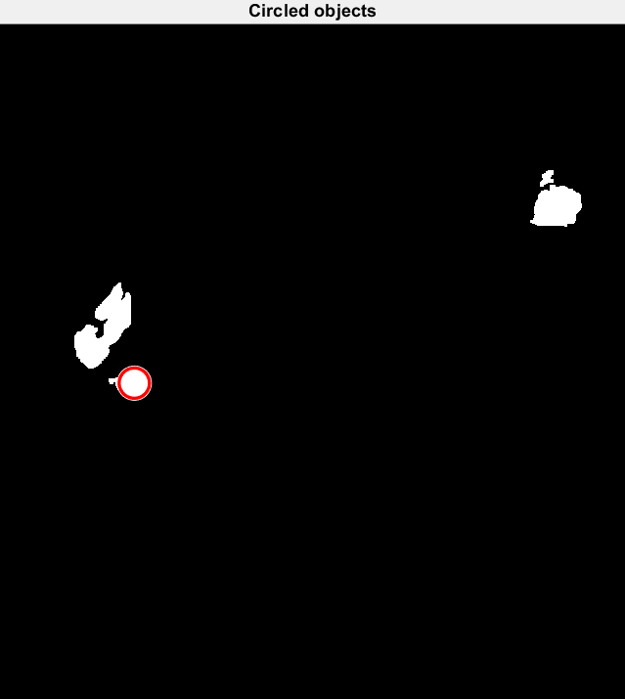

As you can see there are circled objects detected in the above image where we could find the **WBC lymphocyte cells** in the red marked region which are **closer to circular in shape**.

The above mentioned image processing was done for all 36 validation images provided by a professional expertised pathologist and the number of Lymphocytes was validated with the results found.

The results were to clarified by visual representation.

**Results:**

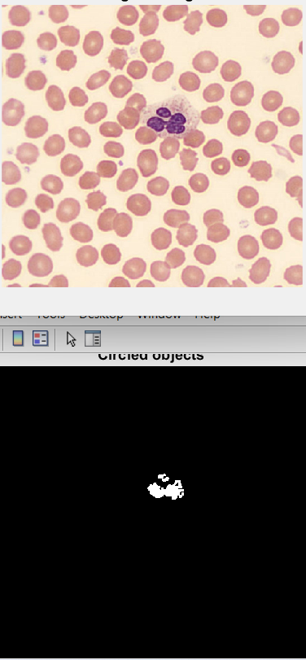 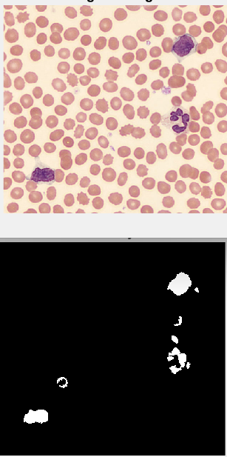 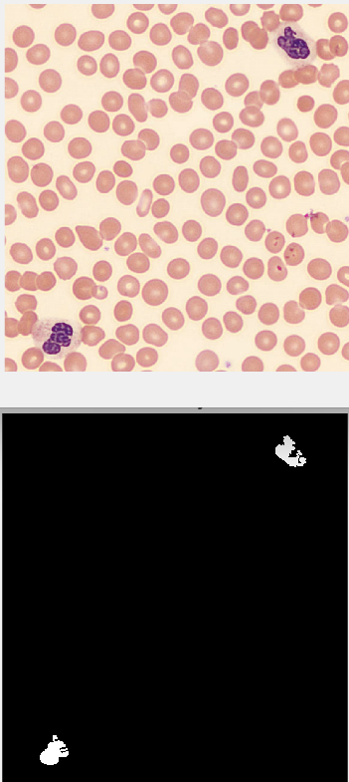 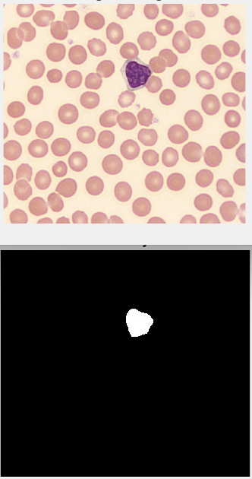

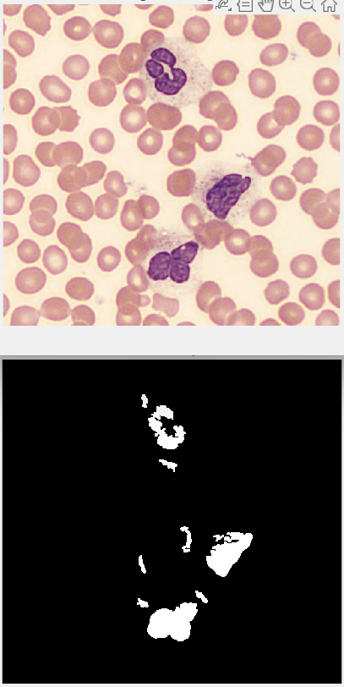 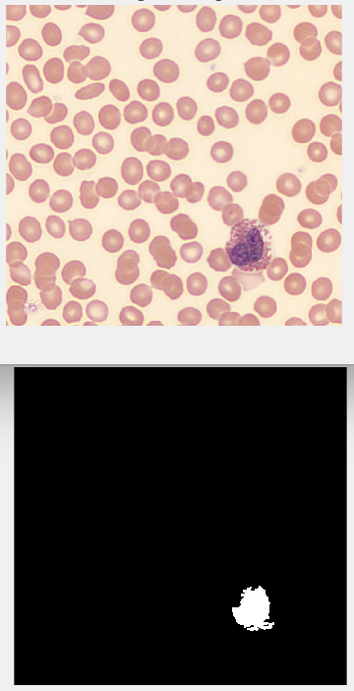 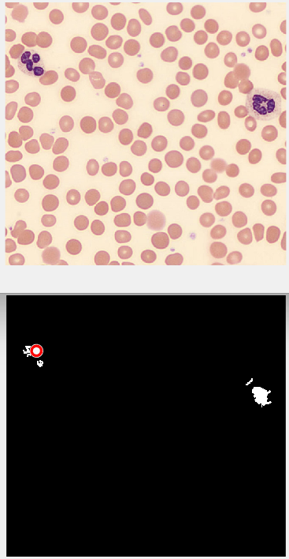 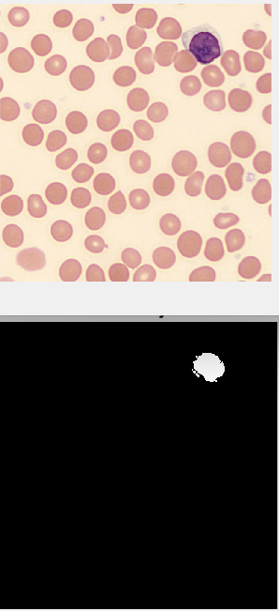

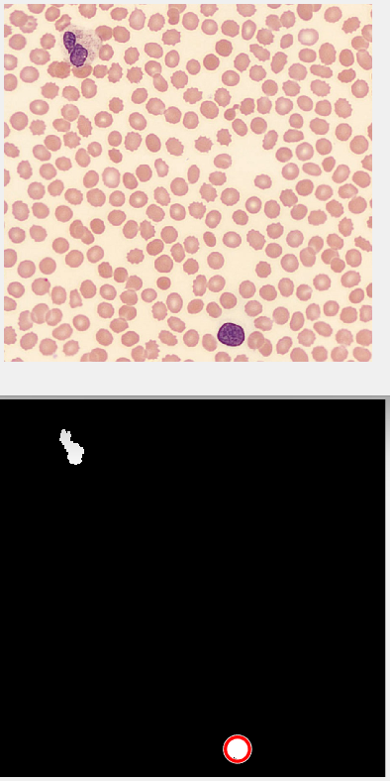 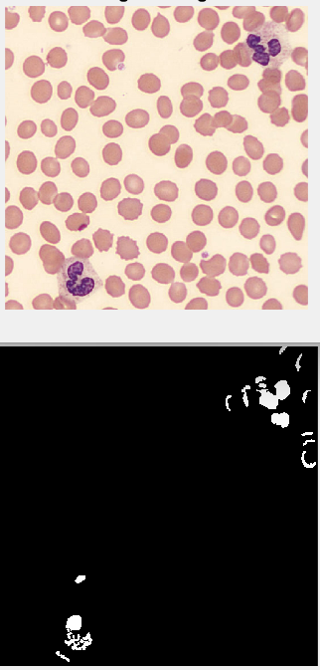 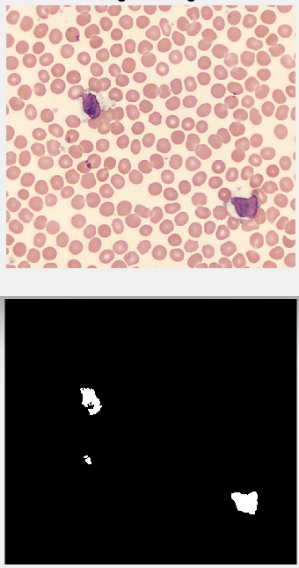 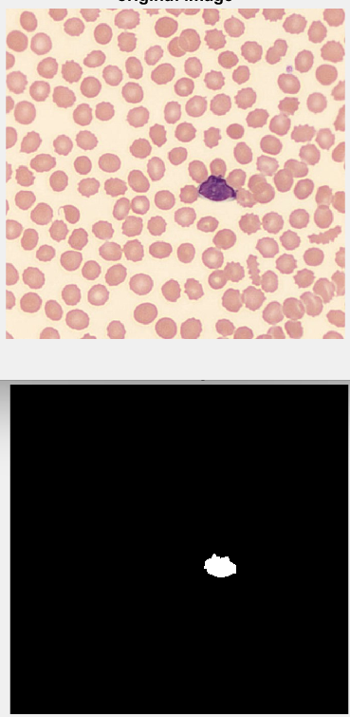

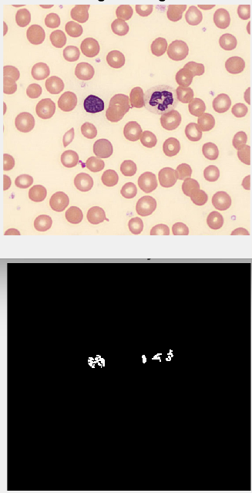 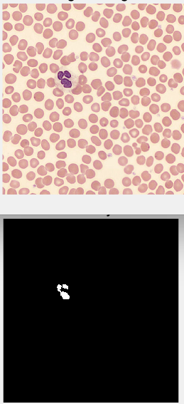 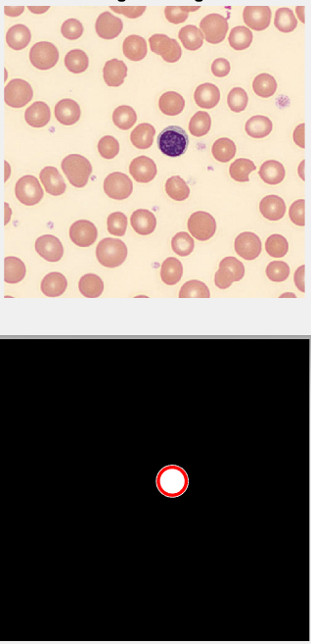 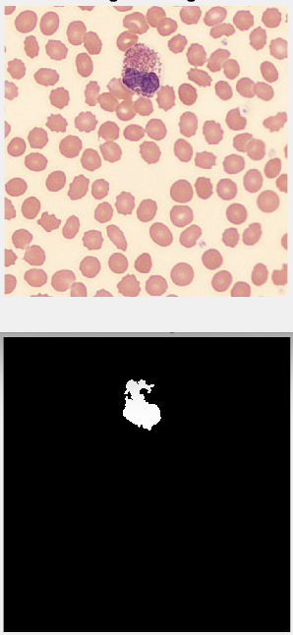

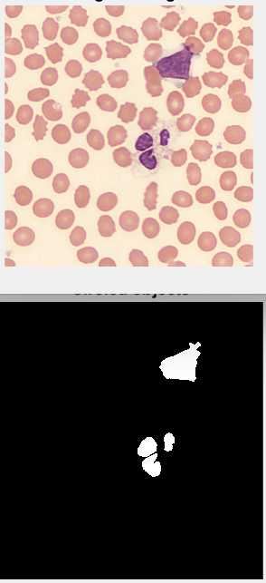 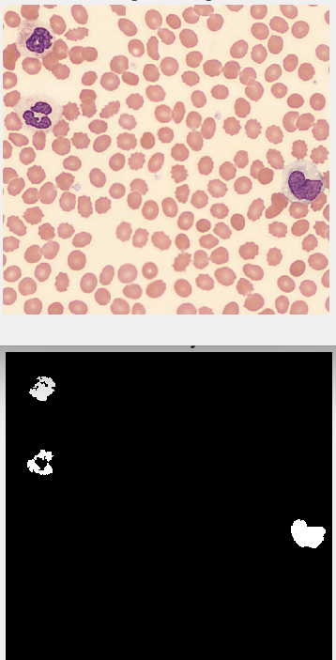 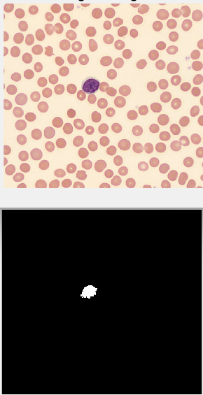 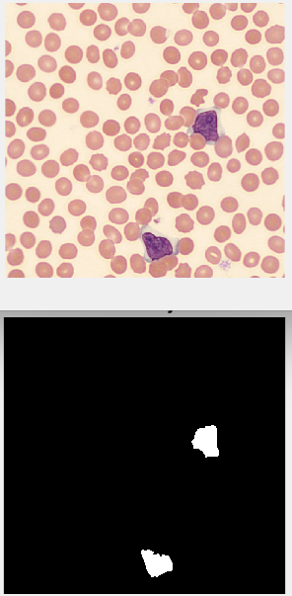

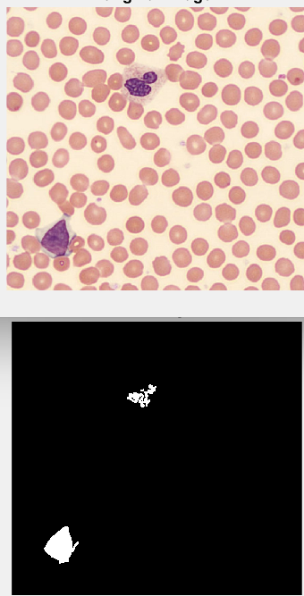 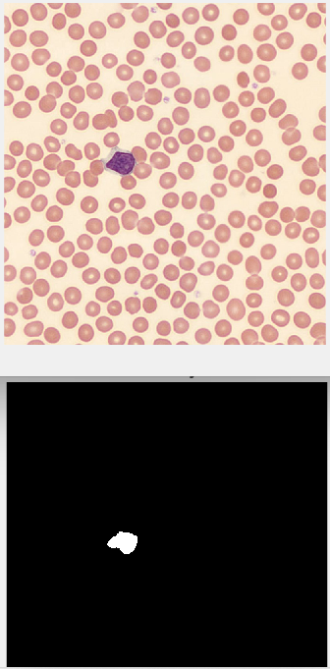 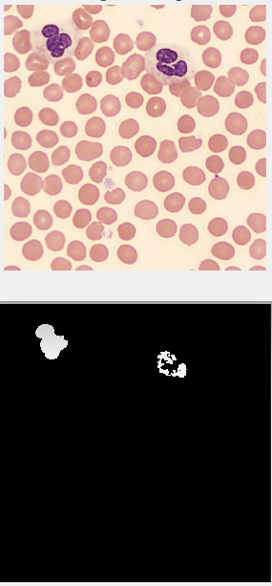 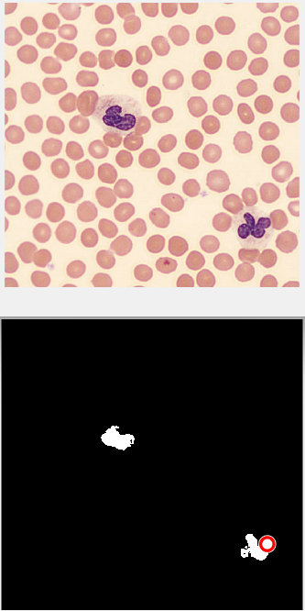

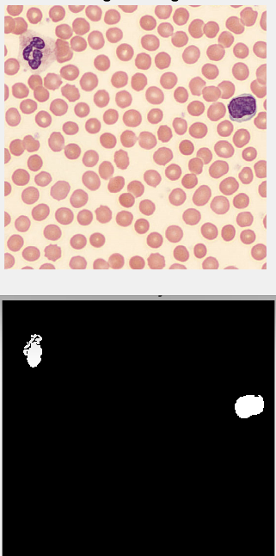 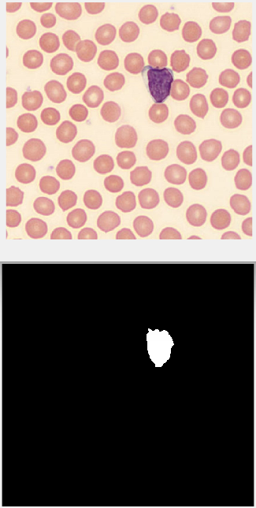 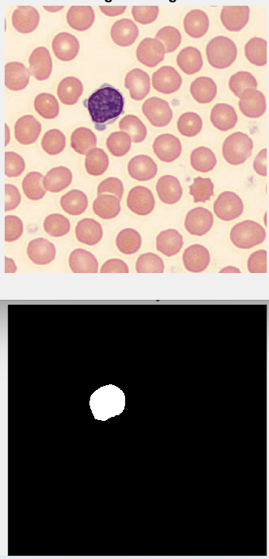 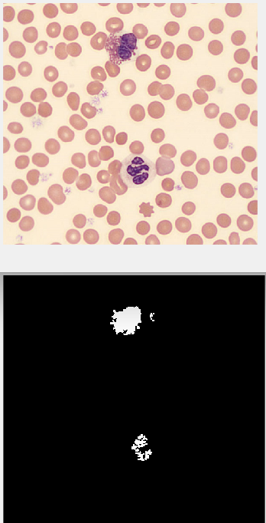

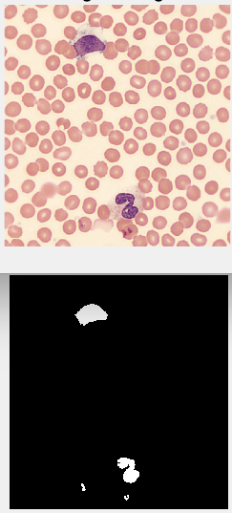 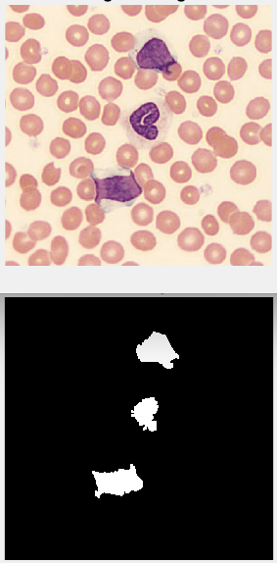 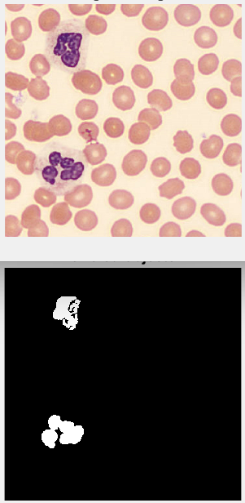 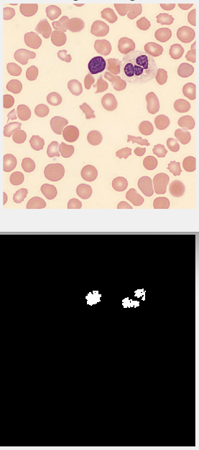

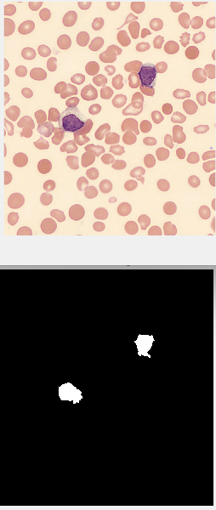 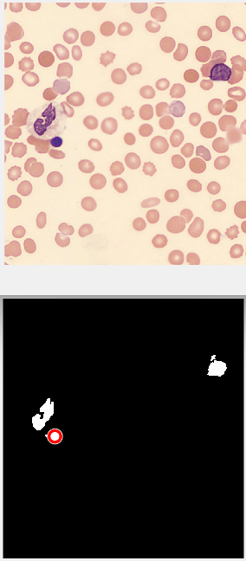 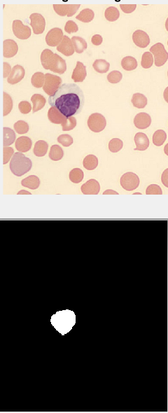 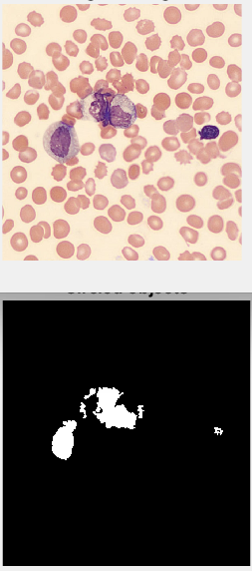

**Conclusion:**

By the validation of images we can create a table as follows;

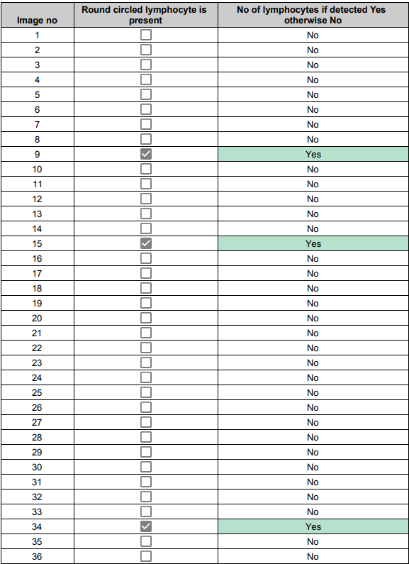

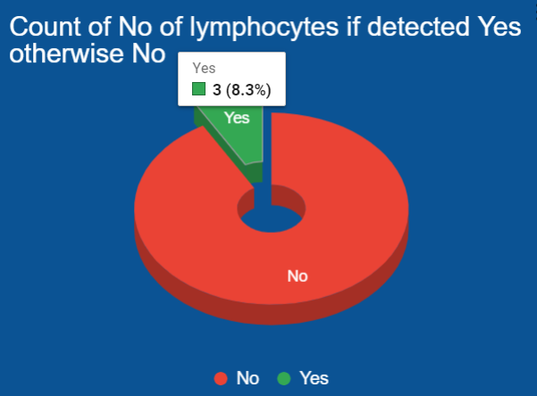 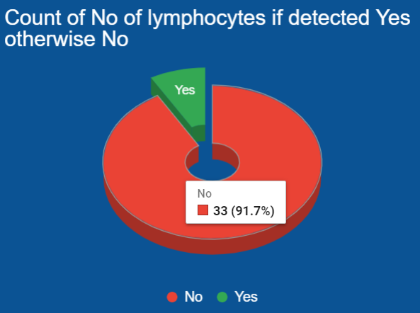

From the above we can understand that the no of images that confirmed a lymphocyte are **3** and the no of images that were not having any lymphocytes are **33.** So most of the images

The presence of these circular shaped lymphocytes detected by image processing correlates with the pathology method.